Name-Ujjawal Mandhani
Enroll No- 9918103237
Batch-F6
COA LAB-1

Question 1:Reliaze the truth table of various gates loke so AND,NOR,NAND....

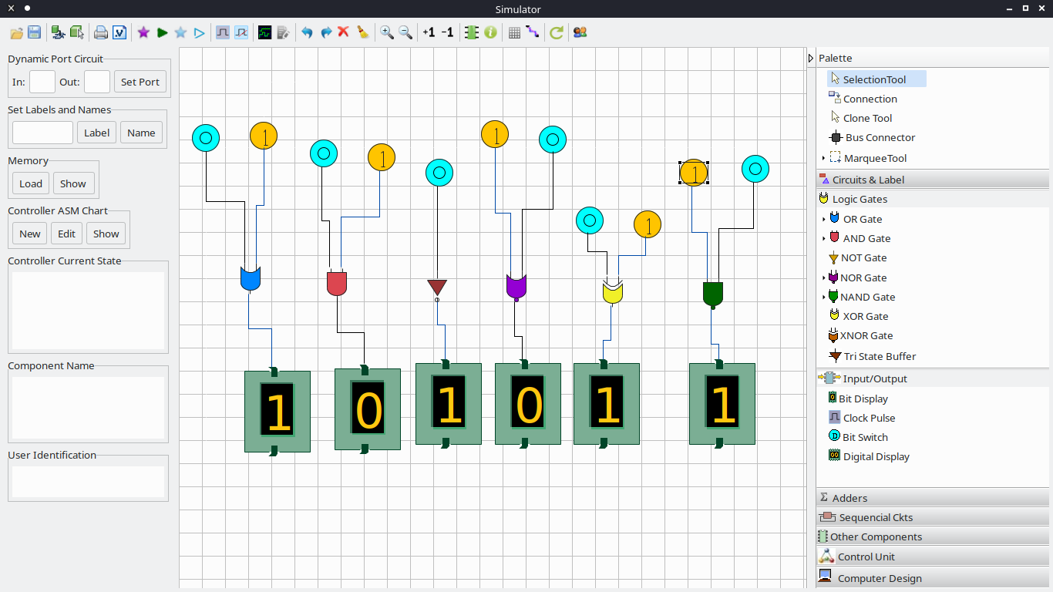
Question 2:Conversion of gates

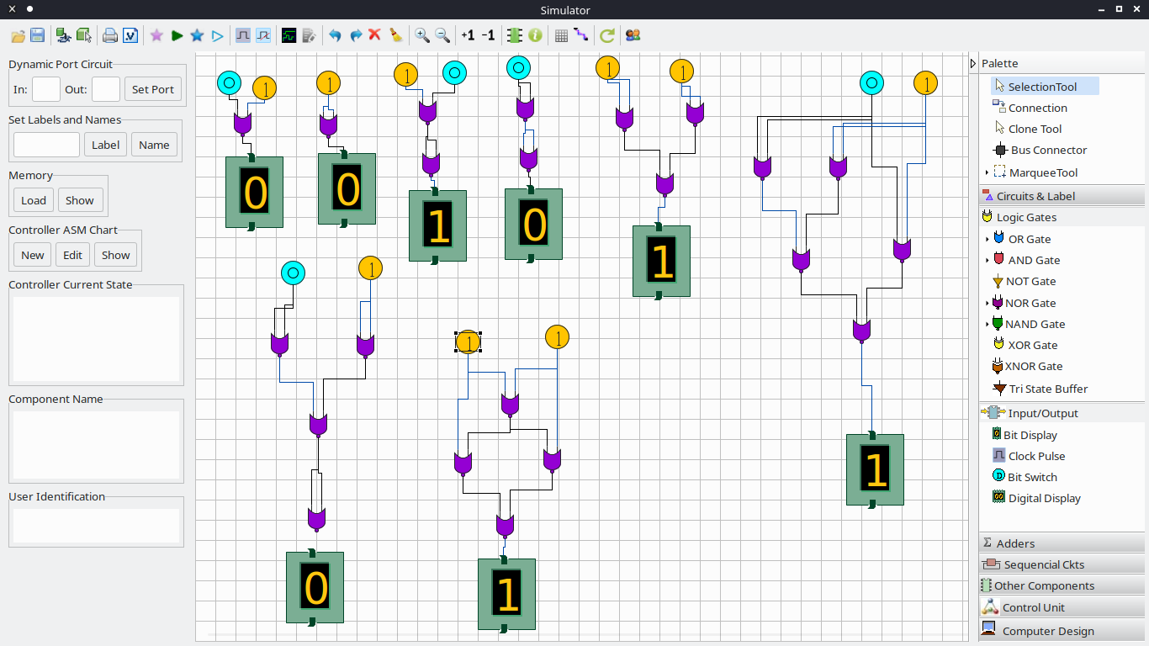
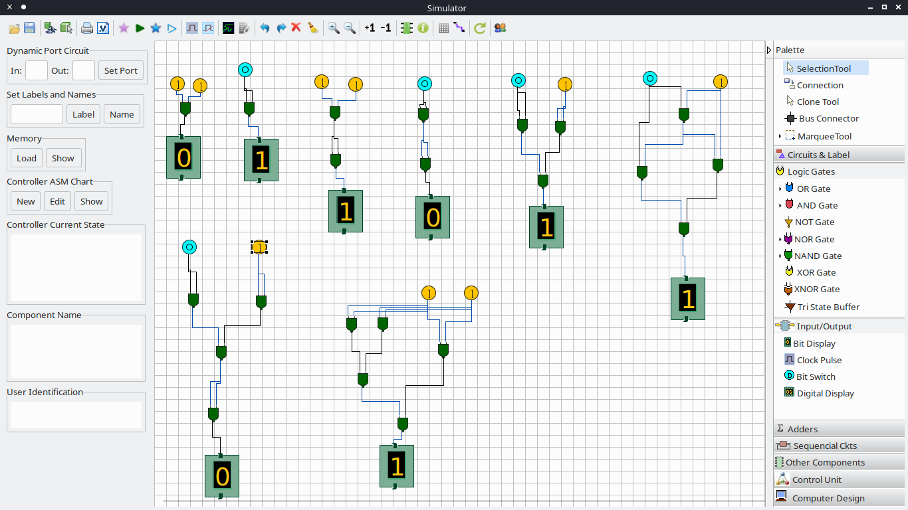
Question 3:Design Half adder and full adder Circuits
Half Adder:
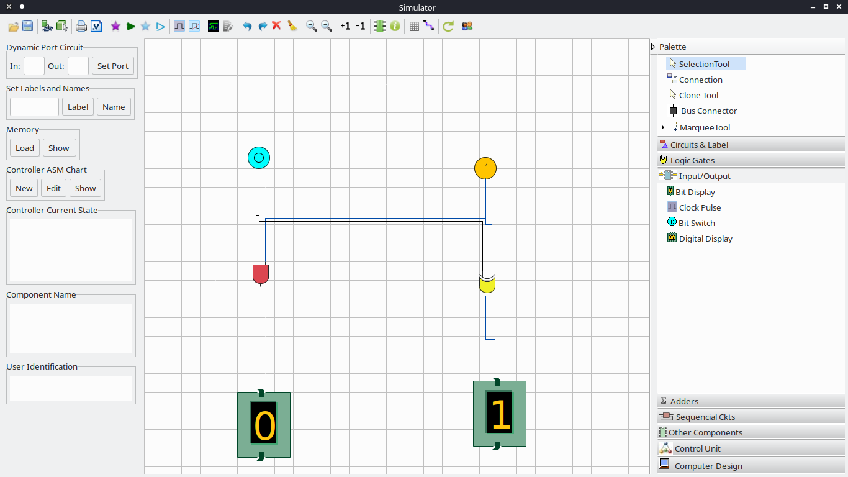
Full Adder:
